Topology Qualifying Examination, August 2012

Instructions
Instructions: Work all problems. Give clear explanations and complete proofs.

Problems
- Let $X=\{(x,sin(1/x))∣x>0\}$ and let $Y=\{(0,y)∣-1≤y≤1\}$. Show that $X∪Y$ is not a path connected subset of $R^{2}$.
- Let $A$ denote a subset of points of $S^{2}$ that looks exactly like the capital letter A. Let $Q$ be the quotient of $S^{2}$ given by identifying all points of $A$ to a single point. Show that $Q$ is homeomorphic to a familiar topological space and identify this space.
- Given an example of a map $f:X→Y$ such that both spaces are connected and the map is a continuous bijection but not a homeomorphism.
- Let $A$ and $B$ be circles bounding disjoint disks in the plane $z=0$ in $R^{3}$. Let $X$ be the subset of the upper half space of $R^{3}$ that is the union of the plane $z=0$ and a (topological) cylinder $C$ that intersects the plane in $∂C=A∪B$. Compute $H_{*}(X)$ using the Mayer-Vietoris sequence.
- Use covering space theory to show that $Z_{2}*Z$, that is, the free product of $Z_{2}$ and $Z$, has two subgroups of index 2 which are not isomorphic to each other.
- Let $f=id_{{RP}^{2}}∨*$ and $g=*∨id_{S^{1}}$ be two maps of ${RP}^{2}∨S^{1}$ to itself where $*$ denotes the constant map of a space to its base point. Show that one map is homotopic to a map with no fixed points, while the other is not.
- Use the classification of surfaces to identify the surface drawn below.
- 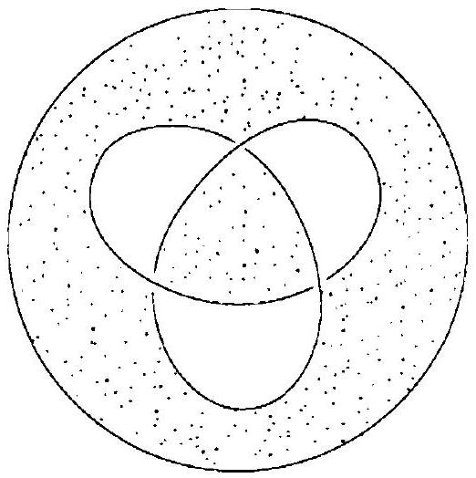
- Denote points of $S^{1}×I$ by $(z,t)$ where $z$ is a unit complex number and $0≤t≤1$. Let $X$ denote the quotient of $S^{1}×I$ given by identifying $(z,1)$ and $(z^{2},0)$ for all $z∈S^{1}$. Give a cell structure for $X$, and use it to compute $π_{1}(X,*)$ and $H_{*}(X)$.

